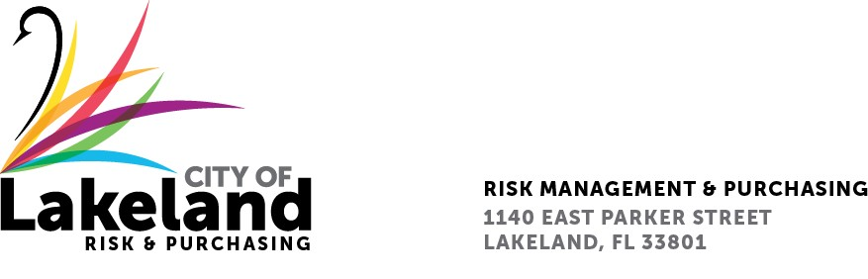

NOTICE

REQUEST FOR QUALIFICATIONS

Exhibit Design, Fabrication and Installation for the Lakeland History and Culture Center

RFQ 2023-RFQ- 027

May 26, 2023
The City of Lakeland Selection Committee for the above referenced RFQ will be meeting on Friday June 2, 2023 at 10:00 a.m. at the City of Lakeland Purchasing Bid Room 2nd Floor located at 1140 East Parker St. Lakeland, FL 33801

In accordance with the Americans with Disabilities Act and Section 286.26, Florida Statutes, persons with disabilities needing special accommodation to participate in this proceeding, or those requiring language assistance (free of charge) should contact the City of Lakeland ADA Specialist, Jenny Sykes, M.S., no later than forty-eight (48) hours prior to the proceeding, at (863) 834-8444, Email: jennifer.sykes@lakelandgov.net. If hearing impaired, please contact the TDD numbers: Local – (863) 834-8333 or 1-800-955-8771 (TDD-Telecommunications Device for the Deaf) or the Florida Relay Service Number 1-800-955-8770 (VOICE), for assistance.

Thank you
Linda Alspaugh
Purchasing/Risk Department
Linda.alspaugh@lakelandgov.net

