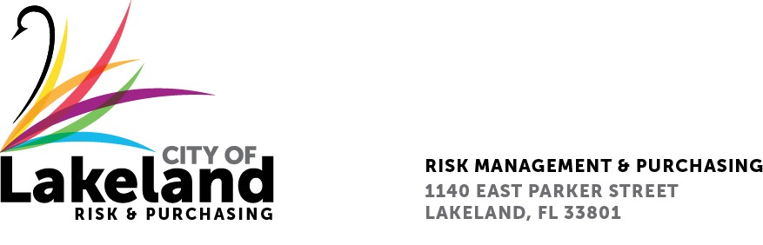

NOTICE

REQUEST FOR PROPOSAL

CAR WASHING SERVICE (EXPRESS, FULL SERVICE, DETAIL)

for the

city OF LAKELAND

RFP 2025-RFP-091

December 4, 2025
The City of Lakeland Selection Committee for the above referenced RFP will be meeting on Wednesday, December 10th at 10:00 a.m. at the City of Lakeland Purchasing Bid room 2nd floor located at 1140 East Parker St. Lakeland, FL 33801

In accordance with the Americans with Disabilities Act and Section 286.26, Florida Statutes, persons with disabilities needing special accommodation to participate in this proceeding, or those requiring language assistance (free of charge) should contact the City of Lakeland ADA Specialist, Kristin Meador , no later than forty-eight (48) hours prior to the proceeding, at (863) 834-8444, Email: kristin.meador@lakelandgov.net If hearing impaired, please contact the TDD numbers: Local – (863) 834-8333 or 1-800-955-8771 (TDD-Telecommunications Device for the Deaf) or the Florida Relay Service Number 1-800-955-8770 (VOICE), for assistance.

